**ADL 331: AI & DATA SCIENCE LAB**

**<Tool used is Jupyter Notebook>**

Experiment 1

Implement a program to perform operations like mean, median, mode, standard deviation, percentile and various data distributions.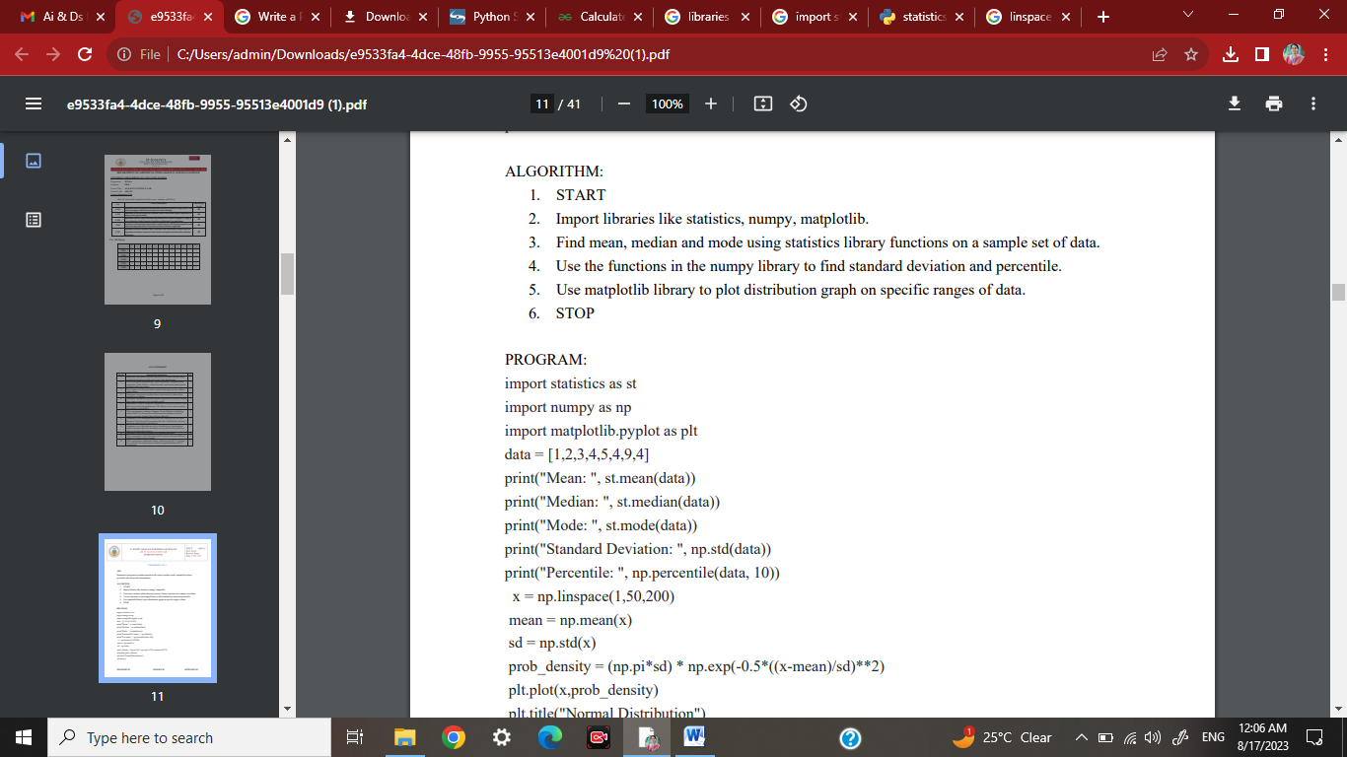

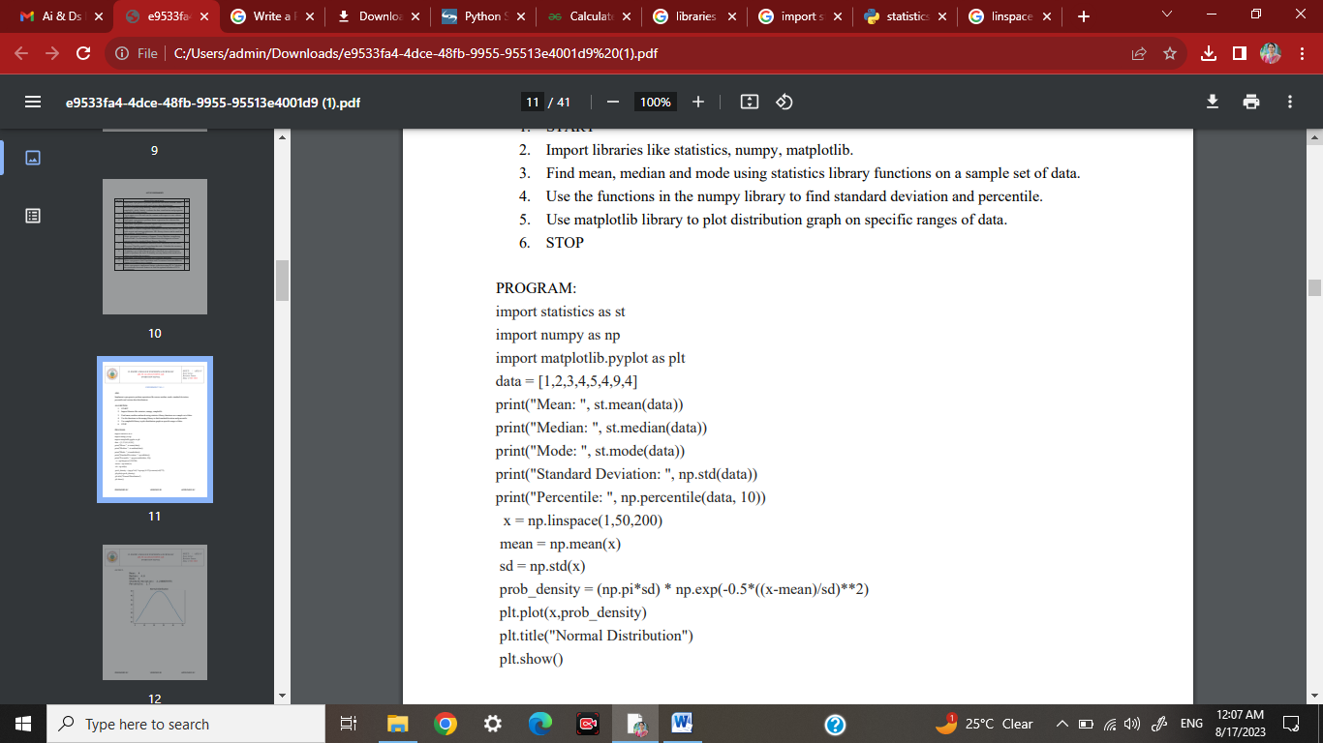

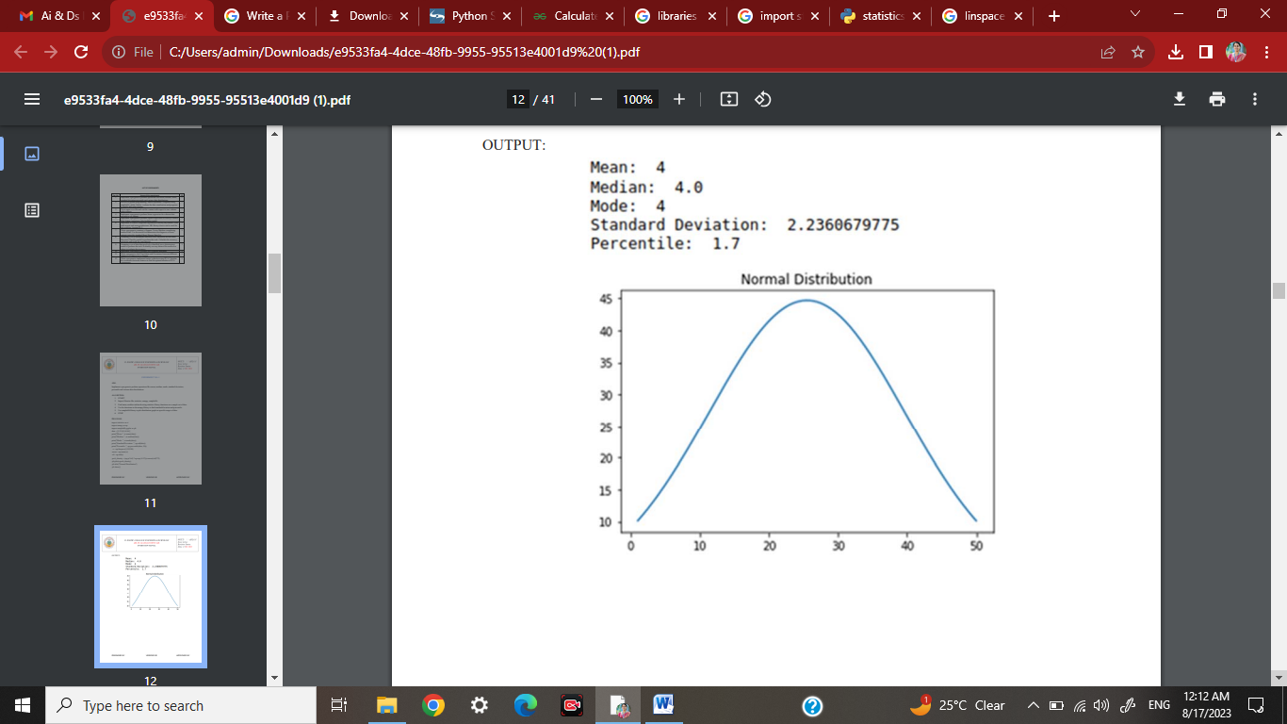

**To be written in the back side of rough record**

**1. What are Jupyter notebooks used for? Why use Jupyter instead of Python?**

**2. What is Numpy?**

**3. Define the terms mean, median, mode, standard deviation, percentile and various data distributions and list the python function used to implement each .**

**4. What is Normal distribution?**

**5. What is the best Python library for plots?**

**6. What is Linspace?**